Testcase validates:

* One record in **D_PI_PRIMARY_PRESENCE_VW corresponds to multiple records in D_PI_PRIMARY_PRESENCE_DAILY_DURATION_VW**
* Daylight conversion
* In **D_PI_PRIMARY_PRESENCE_DAILY_DURATION_VW data in column** PROJECTPRESENCEENDTIME ends in .59.59.00 and starts at 00:00:00.000 next day
* **DURATION** calculation

Table: **D_PI_PRIMARY_PRESENCE_VW**

Query:

select PROJECTID, USERID, PRESENCESTARTDATE, DURATION, ORGANIZATIONPRESENCE, PRESENCESTARTTIME, PRESENCEENDTIME, SYSTEMPRESENCE

from "PUREINSIGHTS_DEV"."PUBLIC"."D_PI_PRIMARY_PRESENCE_VW"

where PROJECTID = 7777 and PROJECTNAME = 'FLCT'

and userid = '06b0e4e6-f728-49fb-b6b2-20daf29f3f74'

and ORGANIZATIONPRESENCE = 'Offline'

and PRESENCESTARTDATE = '2020-07-12';

Data:

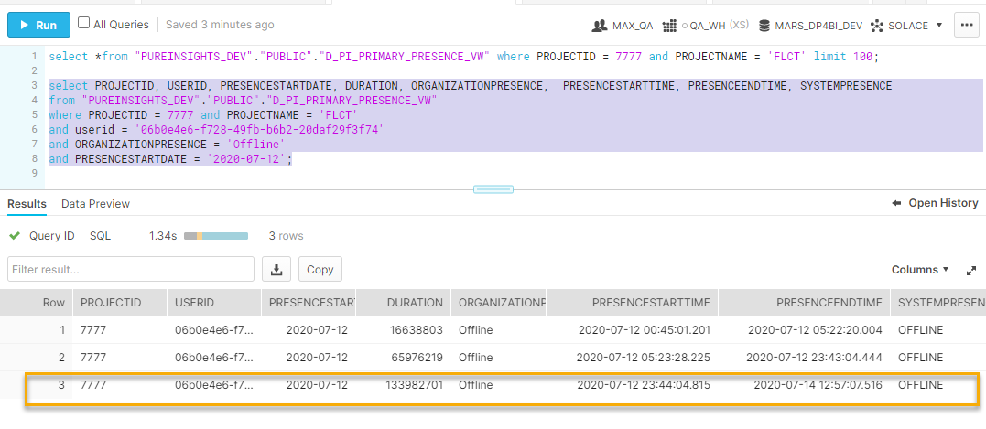

Table: **D_PI_PRIMARY_PRESENCE_DAILY_DURATION_VW**

Query:

select PROJECTID, USERID, PROJECTPRESENCESTARTDATE, PROJECTPRESENCESTARTTIME, PROJECTPRESENCEENDTIME, SYSTEMPRESENCE, DAILYDURATION, TOTALDURATION

from "PUREINSIGHTS_DEV"."PUBLIC"."D_PI_PRIMARY_PRESENCE_DAILY_DURATION_VW"

where PROJECTID = 7777 and PROJECTNAME = 'FLCT'

and USERID = '06b0e4e6-f728-49fb-b6b2-20daf29f3f74'

and SYSTEMPRESENCE = 'OFFLINE'

and PROJECTPRESENCESTARTDATE >= '2020-07-12';

Data:

